………….

Observers and analysts have been increasingly pointing to Warsaw and Poland as a future financial/economic hub of the Central and Eastern Europe region. That is not surprising. Poland, with its geopolitical situation, its level of development and the size of the country's market, has all it needs to play such a role. But what is the best way to achieve this goal? Can politicians, economic leaders and institutions effectively take advantage of propitious circumstances? What is in the way?

We will seek answers to such questions at the second Warsaw—CEE Financial Hub international conference, which will take place at the Warsaw Stock Exchange Nov. 26-27. The conference organizers, along with the Warsaw Stock Exchange, are the International Herald Tribune and
The Warsaw Voice. The conference will be officially hosted by Warsaw City Hall and Warsaw mayor Hanna Gronkiewicz-Waltz. We have also asked the Economy Ministry to be a patron. We are inviting renowned economic authorities, government officials, domestic and foreign investors, market analysts, executives and entrepreneurs who are leaders in key sectors of the economy to attend. I would like to encourage your firm to become a sponsor of this significant conference, which is one of the year's highlight events. I am attaching a list of basic facts about this year's conference along with a price list. Please consider the proposals as preliminary: the final shape of the organizers’ package of commitments will be agreed on after taking into account your individual approach and your actual needs.

On behalf of the conference organizers,
With best regards,

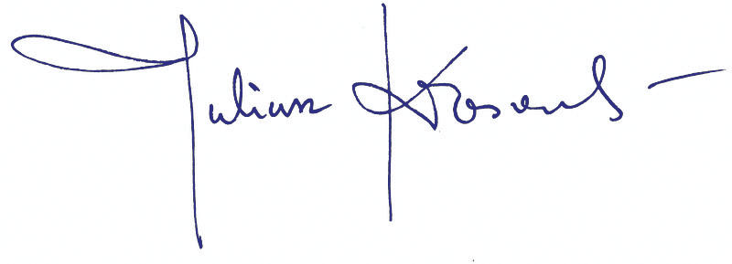

Juliusz Kłosowski,
General Director
The Warsaw Voice

